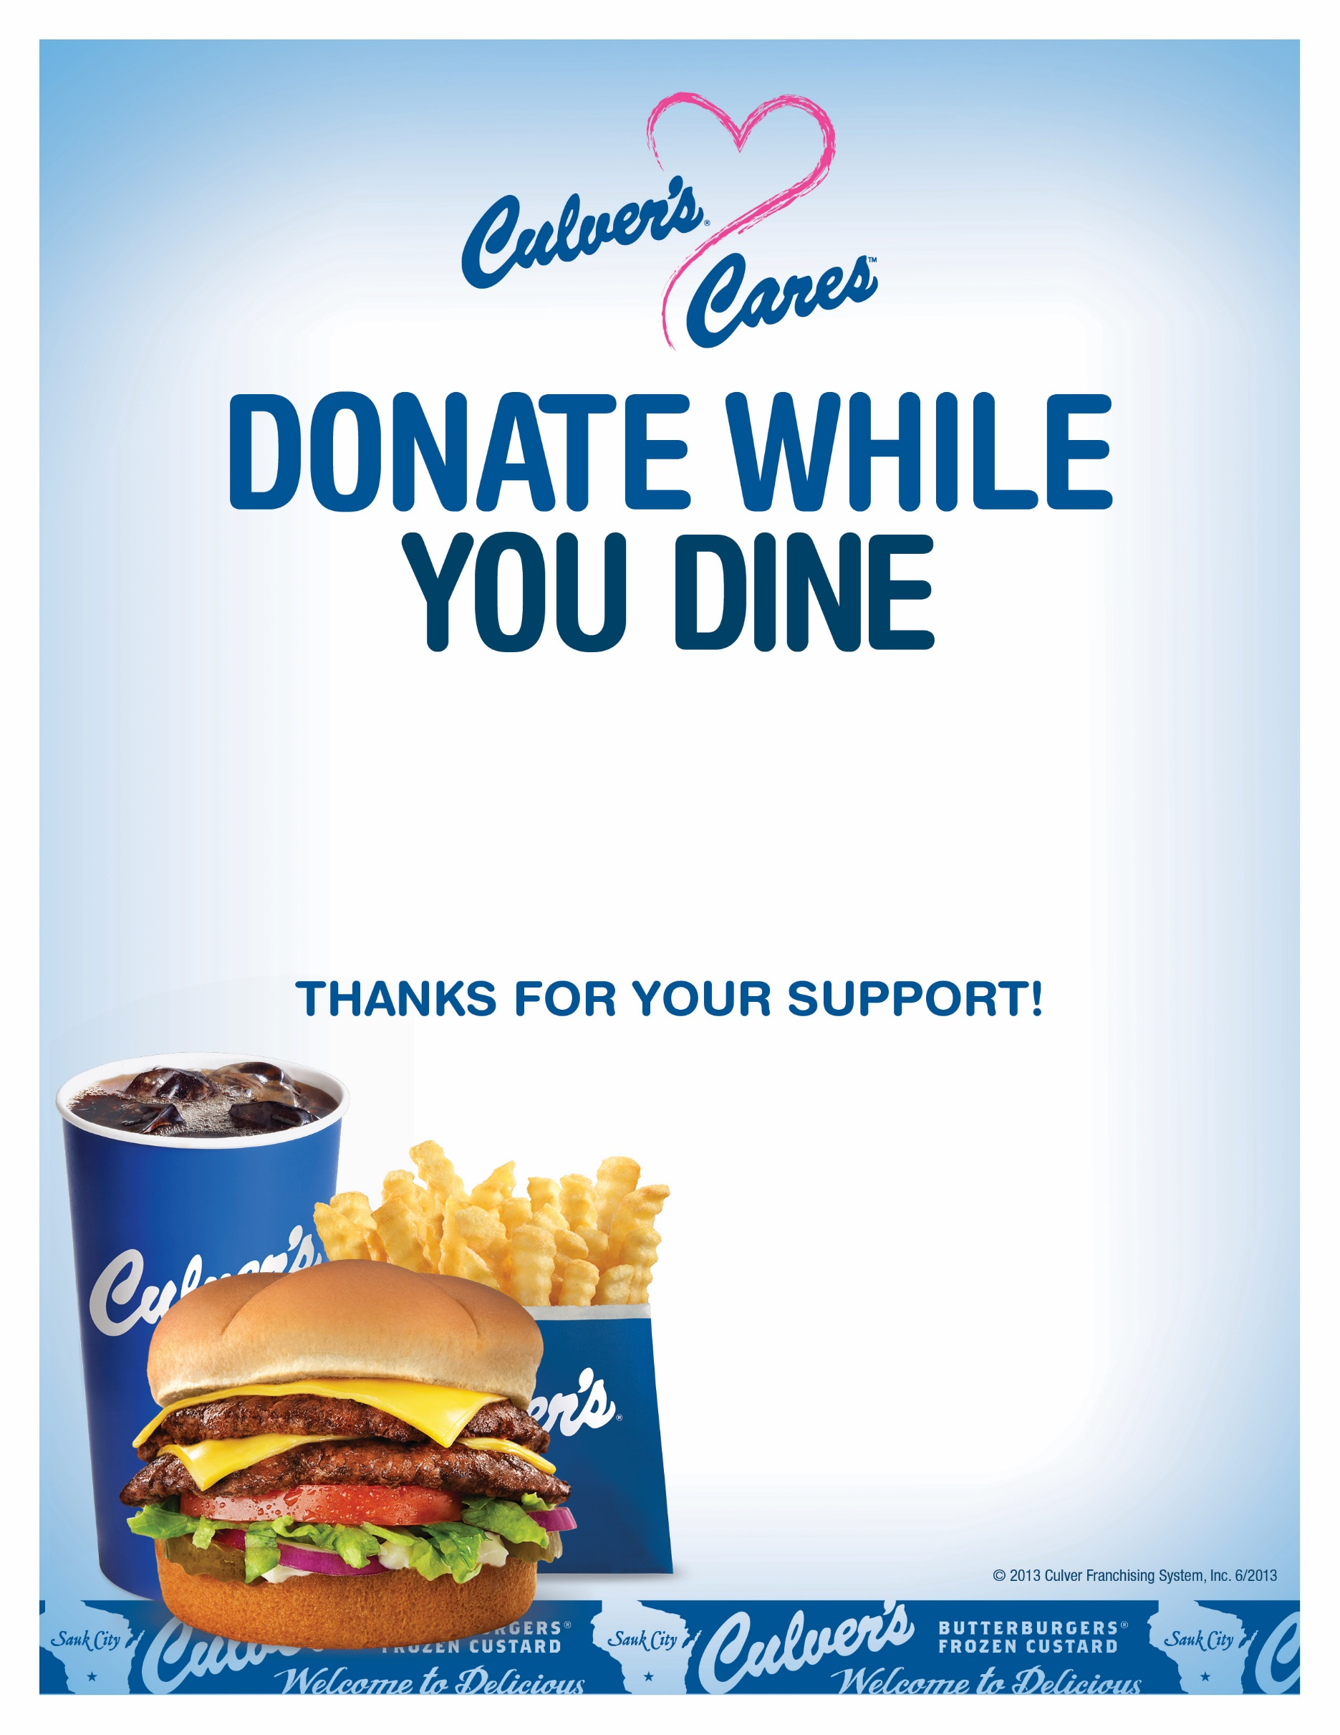

Visit our Culver’s Restaurant on Minnesota Avenue on Wednesday, August 7th, 2024 between 11:00am-2:00pm and 5:00pm-8:00pm and we will donate 10% of our sales to the Lincoln High School Band.

Enjoy a delicious meal, help a local Sioux Falls school, and feel good all over.

